Microsoft BizTalk Adapter for Microsoft Dynamics CRM 4.0
Installation and Usage Guide

August 2009
Information in this document, including URL and other Internet Web site references, is subject to change without notice. Unless otherwise noted, the companies, organizations, products, domain names, e-mail addresses, logos, people, places, and events depicted in examples herein are fictitious. No association with any real company, organization, product, domain name, e-mail address, logo, person, place, or event is intended or should be inferred. Complying with all applicable copyright laws is the responsibility of the user. Without limiting the rights under copyright, no part of this document may be reproduced, stored in or introduced into a retrieval system, or transmitted in any form or by any means (electronic, mechanical, photocopying, recording, or otherwise), or for any purpose, without the express written permission of Microsoft Corporation.

Microsoft may have patents, patent applications, trademarks, copyrights, or other intellectual property rights covering subject matter in this document. Except as expressly provided in any written license agreement from Microsoft, the furnishing of this document does not give you any license to these patents, trademarks, copyrights, or other intellectual property.

© 2009 Microsoft Corporation. All rights reserved.

Microsoft, MS-DOS, Windows, Windows Server, Windows Vista, BizTalk, Great Plains, Microsoft Dynamics, and Visual Studio are either registered trademarks or trademarks of Microsoft Corporation in the United States and/or other countries.

All other trademarks are property of their respective owners.

Contents

Introduction 4
Product Overview 4
Support 4
Installation 5
On Premise: Creating a send port when the BizTalk Server process user is also the Microsoft Dynamics CRM access user 6
On-Premise: Creating a send port when the BizTalk Server process user and the Microsoft Dynamics CRM access user are different 7
Create the host 8
Create the host instance 8
Create the new send handler for the adapter 9
Create the send port with the new send handler 10
IFD: Creating a send port 11
Fetch the schema 12
Run-time Behavior 18
Create a secured log path directory 19
Known Issues 20

Introduction
This document provides product overview and describes the installation and usage of the
Microsoft® BizTalk® Server Adapter for Microsoft Dynamics® CRM 4.0

This document describes how to create a send port for this adapter and fetch schemas from Microsoft Dynamics CRM.

This guide is intended for users who have knowledge of the basic concepts of Microsoft BizTalk Server and Microsoft Visual Studio®.

Product Overview

Release Goal

To enable integration between Microsoft Dynamics CRM and external business applications.

Product Scope

The Microsoft® BizTalk® Server Adapter for Microsoft Dynamics® CRM 4.0 provides following operations.

- Availability of Microsoft Dynamics CRM as a send Adapter
- Discovery and usage of actions/entities schemas for different Microsoft Dynamics CRM organizations.

The user can utilize the above capabilities of the adapter to connect Microsoft Dynamics CRM to other applications via BizTalk server using the BizTalk server orchestration/mapping capabilities.

Support
Support for the Microsoft® BizTalk® Server Adapter for Microsoft Dynamics™ CRM 4.0 is limited to the areas outlined in this Installation and Usage Guide. These areas include:
- Installation
- Creating Send Ports
- Fetching Schema from Microsoft CRM

Installation

Prerequisites for Installation
The following prerequisites must be fulfilled before you run Microsoft BizTalk Adapter for Microsoft Dynamics CRM 4.0 installation.
- One of the following supported versions of BizTalk Server and its pre-requisites are is installed and configured:
  - BizTalk Server 2009
  - BizTalk Server 2006 R2
  - BizTalk Server 2006
- A supported version of Visual Studio installed.
  - BizTalk Server 2009 requires Visual Studio 2008 SP1
  - BizTalk Server 2006 and 2006 R2 require Visual Studio 2005
For more information regarding BizTalk Server pre-requisites, please review the BizTalk Server system requirements page on the BizTalk Server site. Please note that support for these pre-requisites is not included with support for the Adapter install.

Installation Instructions
- Download the .exe file from the Microsoft Download Center.
- Double-click the .exe file. The Installation Wizard opens, to help guide you through the installation.
- After the installation is complete, Microsoft Dynamics CRM 4.0 appears in the list of adapters in the BizTalk Server Administration Console, as shown in Figure 1. The BizTalk Server Administration Console is installed with Microsoft BizTalk Server.
- User has to be local administrator and member of "SSO Administrators" group to perform the installation.
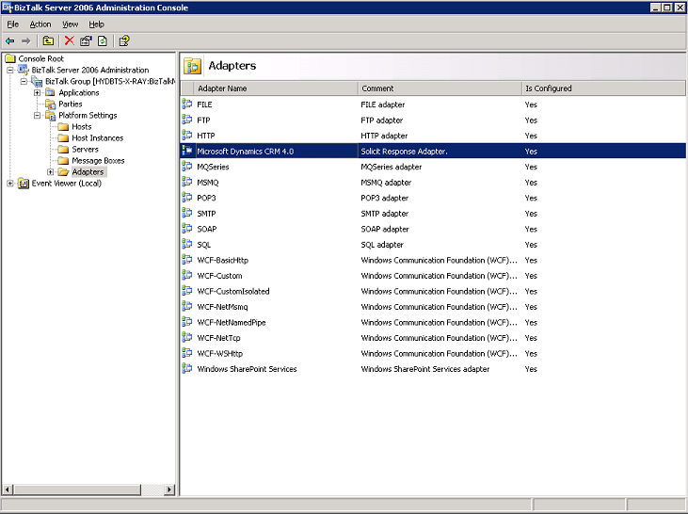
Figure 1

On Premise: Creating a send port when the BizTalk Server process user is also the Microsoft Dynamics CRM access user
Follow these steps to create the send port when the BizTalk Server process is running under the credentials of a Microsoft Dynamics CRM access user.

Note: The steps listed below are for Microsoft BizTalk Server 2006. The same steps may be used for BizTalk Server 2009 by using the corresponding application links in the Microsoft BizTalk Server 2009 folder on the Start menu.

- Click Start, point to Microsoft BizTalk Server 2006 , open BizTalk Administration and expand Applications, and then expand BizTalk Application 1.
- Right-click Send Ports, point to New, and then select desired port type.
- If the selected port type is Static, then follow steps 5-9 to specify the Send Handler.
- If the port type is Dynamic, no need to create a Send Handler as the Dynamic port will use the default Send Handler.
- The Send Port Properties dialog box opens, as shown in Figure 2.
- In the Name box, type the name of the send port.
- In the Type list, select Microsoft Dynamics CRM. Click Configure to provide Microsoft Dynamics CRM URL, select AD authentication and choose from populated organizations.
- In the Send handler list, verify that the default BizTalkServerApplication is selected.
- In the Send pipeline list, select XML Transmit or, if you are using a two-way solicit response port, select XML Receive for the response pipeline.
- Click OK.

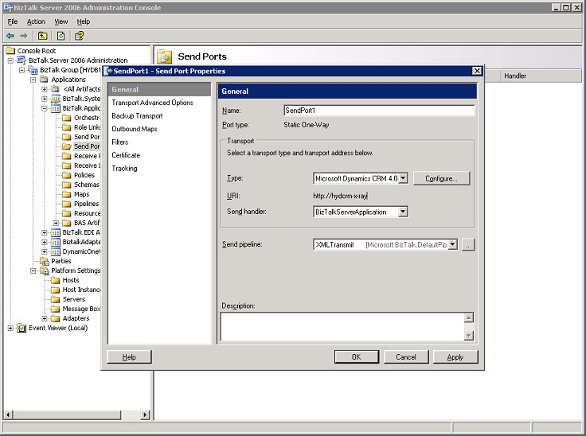
Figure 2

On-Premise: Creating a send port when the BizTalk Server process user and the Microsoft Dynamics CRM access user are different

Follow these steps to create a send port when the Microsoft Dynamics CRM access user has different credentials than the BizTalk Server process user, or if you are configuring multiple send ports to multiple Microsoft Dynamics CRM servers.

This scenario has the following steps:

- Create the host.
- Create the host instance.
- Create the new send handler for the Microsoft Dynamic CRM adapter.
- Create the send port with the new send handler.

Note: The steps listed below are for Microsoft BizTalk Server 2006. The same steps may be used for BizTalk Server 2009 by using the corresponding application links in the Microsoft BizTalk Server 2009 folder on the Start menu.

Create the host
- Click Start, point to Microsoft BizTalk Server 2006, open BizTalk Administration, and expand Platform settings.
- Right-click Hosts, point to New, and select Host.
The Host Properties dialog box opens, as shown in Figure 3.
- In the Name box, type a host name.
- In the Type list, select In-Process.
- In the Windows group box, enter the name of the BizTalk Application Users or BizTalk Server Administrators group, and then click OK.

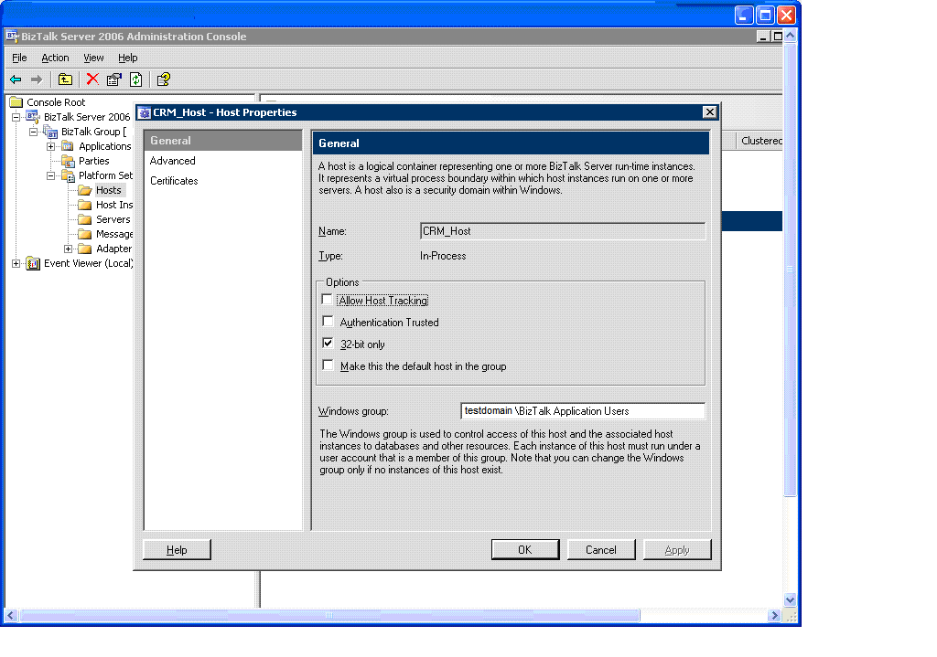
Figure 3

Create the host instance
- Click Start, point to Microsoft BizTalk Server 2006, open BizTalk Administration, and expand Platform Settings.
- Right-click Host Instances, point to New, and then click Host Instance. The Host Instances Properties dialog box opens, as shown in Figure 4.
- In the Host name list, select a name.
- In the Server list, select a server.
- Click Configure. The Logon Credentials dialog box opens.
- In the Logon and Password boxes, type the domain logon name and password of the Microsoft Dynamics CRM access user. These are the credentials used for the host instance to run and for the send handler that will be created (as explained in the next procedure) for the Microsoft Dynamics CRM adapter under this host. Verify that this user is part of the BizTalk Application Users group.
- Click OK.

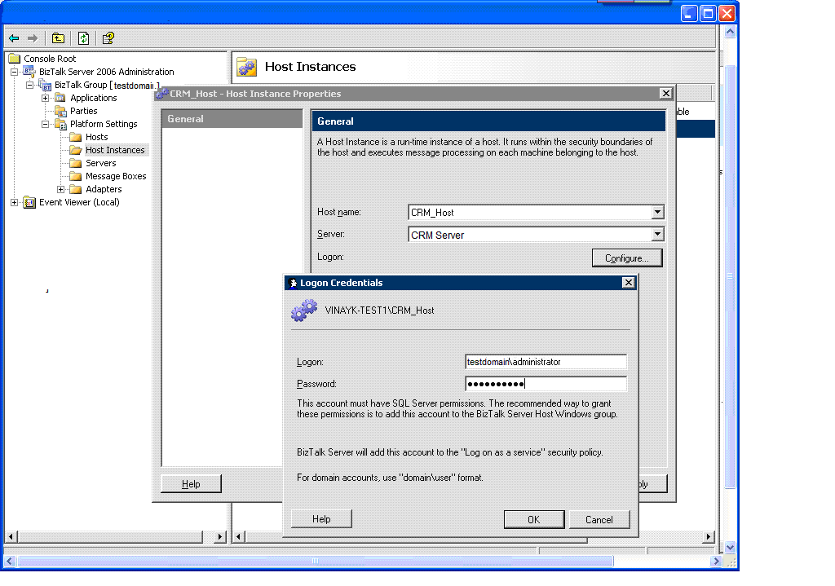
Figure 4

Create the new send handler for the adapter
- Click Start, point to Microsoft BizTalk Server 2006, open BizTalk Administration, and then expand Platform Settings.
- Expand the Adapters node, and then select Microsoft Dynamics CRM.
- Right-click Microsoft Dynamics CRM 4.0, point to New, and then click Send Handler. The Microsoft Dynamics CRM – Adapter Handler Properties dialog box opens, as shown in Figure 5.
- In the Host name list, select the host that you created in the previous procedure, and then click OK.
- To start (or restart) the host instance, right-click the host instance, and click Start (or Restart).

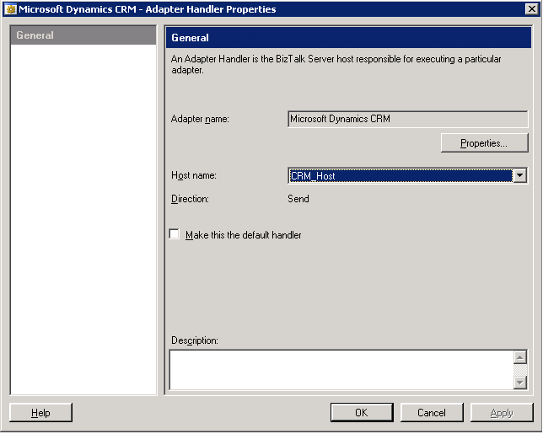
Figure 5

Create the send port with the new send handler
- Click Start, point to Microsoft BizTalk Server 2006, open BizTalk Administration and expand Applications, and then expand BizTalk Application 1.
- Right-click Send Ports, point to New, and then select either Static One-Way Port or Static Solicit Response Port.
The Send Port Properties dialog box opens, as shown in Figure 6 a.
- In the Name box, type a name for the send port.
- In the Type list, select Microsoft Dynamics CRM 4.0. Click Configure to provide Microsoft Dynamics CRM URL , select AD authentication and select from populated organizations.
- In the Send handler list, select the host created in the previous procedure.
- In the Send pipeline list, select XML Transmit or, if you are using a two-way solicit response port, select XML Receive, and then click OK.

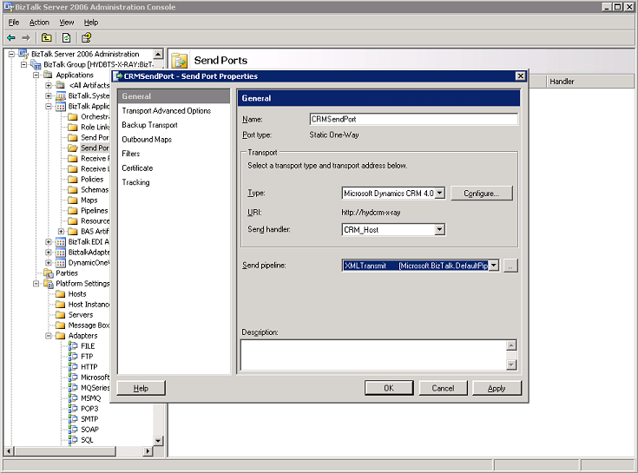
Figure 6a

IFD: Creating a send port
The adapter needs the external domain credentials to communicate with Microsoft Dynamics CRM 4.0 IFD installations. All the steps are valid to the above on-premise installations for the Microsoft Dynamics CRM 4.0, except when configuring send port, one has to select Form Based Authentication and provide the IFD credentials after clicking the configure button during the send port creation. See figure 6 b below.
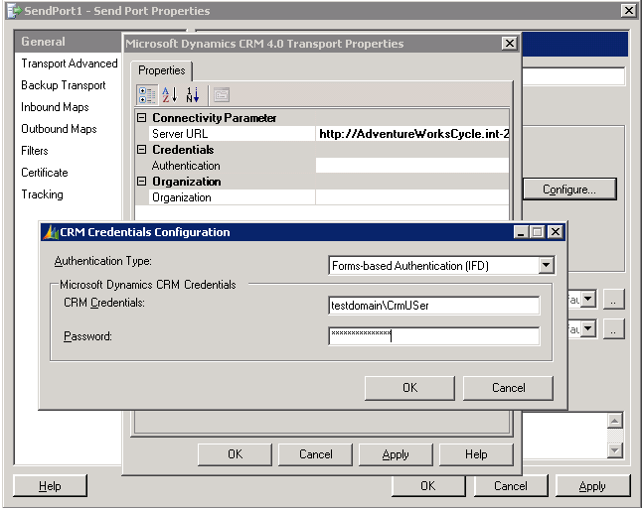
Figure 6b

Fetch the schema
Follow these steps to fetch the entities or actions schemas from Microsoft Dynamics CRM.

Note: The steps listed below are for Microsoft Visual Studio 2005. The same steps may be used for Visual Studio 2008 by using the corresponding application links in the Microsoft Visual Studio 2008 folder on the Start menu.

- Click Start, point to Programs, point to Microsoft Visual Studio .NET, and then click Microsoft Visual Studio .NET.
- In Visual Studio .NET, on the File menu, point to New, and then click Project.
The New Project dialog box opens, as shown in Figure 7.
- In the Solution Explorer window, right-click BizTalk Server Project, point to Add, and then click Add Generated Items.
The Add Generated Items dialog box opens, as shown in Figure 8.
- Under Categories, select Add Adapter Metadata, and then click Add.
The Add Adapter Wizard opens, as shown in Figure 9.
- From the list of registered adapters, select Microsoft Dynamics CRM 4.0.
- In the Port list, select the port created in the previous procedure, and then click Next.
The Microsoft Dynamics CRM User Credentials dialog box appears, as shown in Figure 10 a (on-premise) and 10 b (IFD).
- In the Authentication Type drop-down, select AD for on-premise and form-based authentication for IFD. For User Name and Password input boxes type the user name and password of the Microsoft Dynamics CRM user. Click Get CRM organizations and make the organization selection and click OK. The Microsoft Dynamics CRM Entities and Actions dialog box appears, as shown in Figure 11.
- Expand the tree view shown for the list of Entities and Actions by clicking on the ‘+’ sign. Figure 12 shows an expanded list.
- Select the check boxes for all entities or actions for which schemas are to be fetched, and then click Next. The fetched schemas are displayed in the Solution Explorer view of Visual Studio, as shown in Figure 13.i

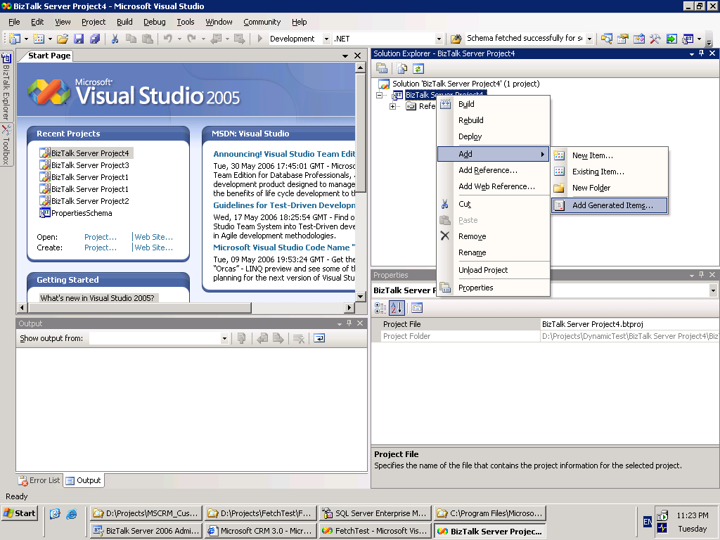
Figure 7

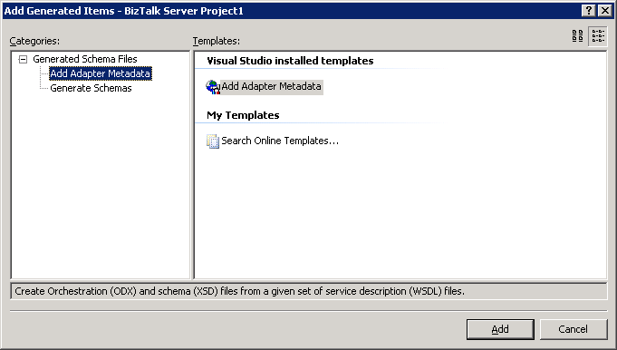
Figure 8

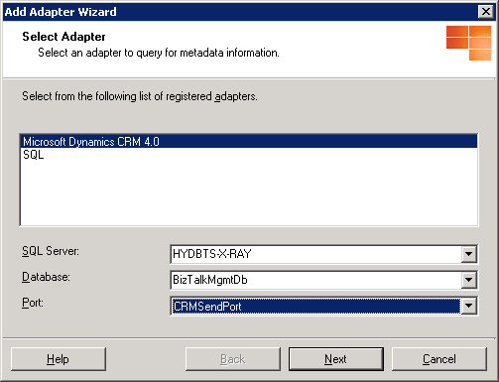
Figure 9

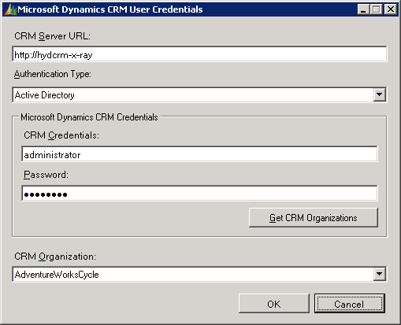
Figure 10 a

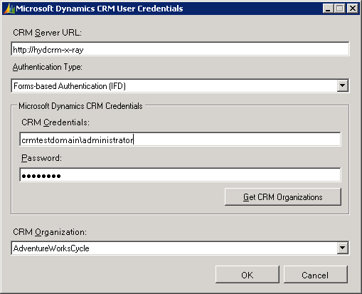
Figure 10 b
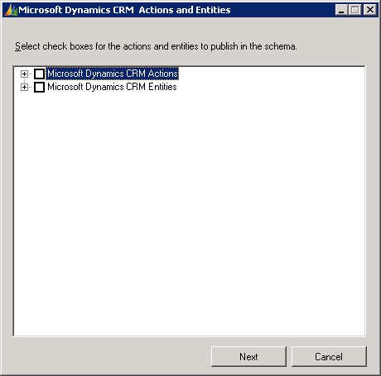
Figure 11

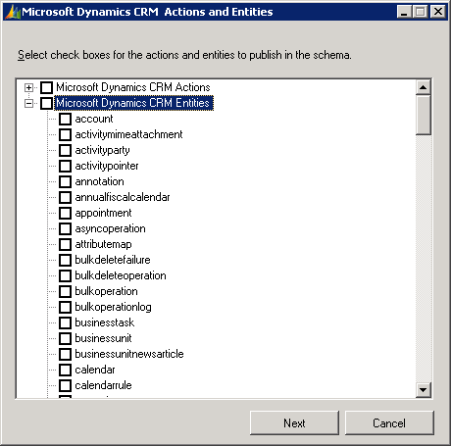
Figure 12

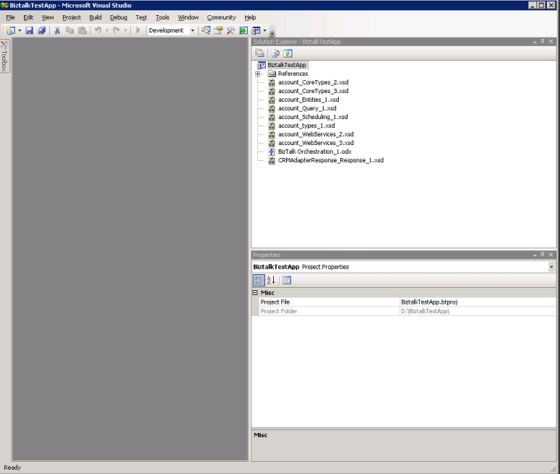
Figure 13

Run-time Behavior
The Microsoft BizTalk Adapter for Microsoft Dynamics CRM 4.0 processes the XML sent from BizTalk Server and performs the Create, Update, and Delete actions of any entities and all other possible actions supported in Microsoft Dynamics CRM 4.0 based on the values present in the incoming XML.

There is an attribute named “crm_action” in the root node of entity and action schemas.
Following is the behavior of Microsoft BizTalk Adapter for Microsoft Dynamics CRM 4.0 when the incoming XML (the transformed /mapped XML) is received,
if:
  - “crm_action” attribute is empty:
      - If the primary key node of the entity (for example accountid for Account) is not present in the XML or if the node has an empty value, the adapter assumes this is a “create” action.
      - If the primary key node of the entity has a correct GUID value, the adapter assumes the action to be “update”.
  - “crm_action” attribute contains some value:
      - If the action is “create”, “update” or “delete”, perform create, update and delete respectively.
      - If the action is “execute”, this adapter performs the action requested using the Microsoft Dynamics CRM SDK. Some examples of actions are ConvertQuoteToSalesOrderRequest, ConvertProductToKitRequest, and SetStateAccountRequest. For a complete reference of all possible actions, see the Microsoft Dynamics CRM 4.0 SDK.

A special case: If you want to perform a create action where you want to specify the GUID for the entity beforehand. For example, you want to create an account where the account id is “{684FD04E-E515-491f-AF25-F9258A3C9F03}”.
Solution:
    - The input XML to the adapter (which can be the result of a map transformation) should contain the following nodes with the specified values.
      - <accountid> {684FD04E-E515-491f-AF25-F9258A3C9F03} </accountid>
      - crm_action=”create” [crm_action is an attribute.]

Create a secured log path directory
You can use a debug feature to check whether the map used in the orchestration is generating the correct XML for Microsoft Dynamics CRM SDK.
This feature is toggled using a registry setting. When Debug = true in the registry, the adapter checks the values in the XML (which results from a transformation/map in orchestration) against all attributes of an entity and their permissible values.

Warning: Modifying the registry incorrectly can cause serious problems that may require you to reinstall your operating system. Microsoft cannot guarantee that problems resulting from the incorrect use of the registry can be solved. Use the registry at your own risk.
If there are incorrect values in the XML, an error is logged in a log file that is created in a directory specified by the registry key “LogPath” in the same registry path where “Debug” is present.
Important: The registry path is “HKEY_CLASSES_ROOT\CLSID\{D38D5DCC-2B30-43b9-9C69-3BBFD0926986}”. This directory must be protected with the appropriate permissions and credentials so that only a user who has the appropriate credentials and permissions can create and access log files in this directory.

Known Issues
- Deletion of any entities does not return the GUID in the response XML returned by Microsoft Dynamics CRM.

- User is able to fetch list of entities and actions using <wrong domain>\ <right login> <right password> if the machine is a domain controller.

- Compilation of BizTalk project fails if following steps are not performed after fetching the schema. User has to set the correct reference in Orchestration for the schema that has been fetched. Please follow the steps given below to avoid compilation failure.
  - Open up the Orchestration.
  - Go to the Orchestration View, expand “Types”, expand “Multi-Part Message Types”, expand <name of the schema fetched + Request> node, click parameters.
  - In the property window, click the dropdown list next to the field “Type” and select the fetched schema.
  - Save the Orchestration and compile it.

